“Hi” recognition:
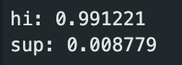
“Sup” recognition:
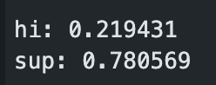
Software issues:
There were 2 main issues with the code. Firstly, the loss function was MSE even though we were building a classification model. MSEs do not make sense for classification models, only for regression ones. I corrected that to binary cross-entropy as the loss function. Also, the metric being used was MAE. Again, this is a regression metric. We must use “accuracy” for classification models.
Changes:
To correct the downstream effects of the change in loss and metric, I had to change the constant METRIC_TO_PLOT to “accuracy” to account for the changes I’d made above.

